MINISTRY OF EDUCATION AND SCIENCE OF UKRAINE

NATIONAL TECHNICAL UNIVERSITY

“KHARKOV POLYTECHNICAL INSTITUTE”

LABORATORY WORK № 2

# “C++ Operators and Statements”

Created by student of 1.КН.201.8г

Chukwu Irele Omike

Checked by

LUTENKO I.V

KHARKIV 2018

# Topic: C++ Operators and Statements.

Goal: Learning to write algorithms with operators and Statement.

Tasks:

1.Develop a program that implements an algorithm for solving quadratic equation. The algorithm should consider all possible data.

2.Develop a program that implements an algorithm for calculating the following expression. Provide a check of possible errors.

y = 1/(x + 2) + 2/(x + 4) + ... + (k - 1)/(x + 2(k - 1)) + (k + 1)/(x + 2(k + 1)) + ... + n/(x + 2n)

3.Write a program that reads x and n and calculates y:  
 y = (x + 1)(x - 2)(x + 3)(x - 4) ... (x - 2n)

4.Write a program that reads eps and calculates y:

y = 1/2 + 1/4 + 1/8 + 1/16 + ...  
The loop terminates if new summand is less than eps.

5.Develop the code for the task from previous lab..(individual Assingment)

Task 1 : The code

#include<iostream>

#include<math.h>

using namespace std;

int main()

{

double D, a, c, b, x1, x2;

cout << "this program calculates the 2nd degree equations" << endl;

m1: cout << endl << "Enter a value" << endl;

cin >> a;

cout << endl << "Enter c value" << endl;

if (a == 0) {

cout << "Invalid data" << endl;

goto m1;

}

cin >> c;

cout << endl << "Enter b value" << endl;

cin >> b;

D = pow(b, 2) - 4 * a*c;

if (D >= 0)

{

x1 = (-b + sqrt(D)) / 2 * a;

x2 = (-b - sqrt(D)) / 2 * a;

cout << "result" <<endl<<"x1:"<< x1 << endl <<"x2:"<< x2<<endl;

}

else

{

cout << "there isnt real roots" << endl;

}

system("pause");

return 0;

}

Task 1: Execution result

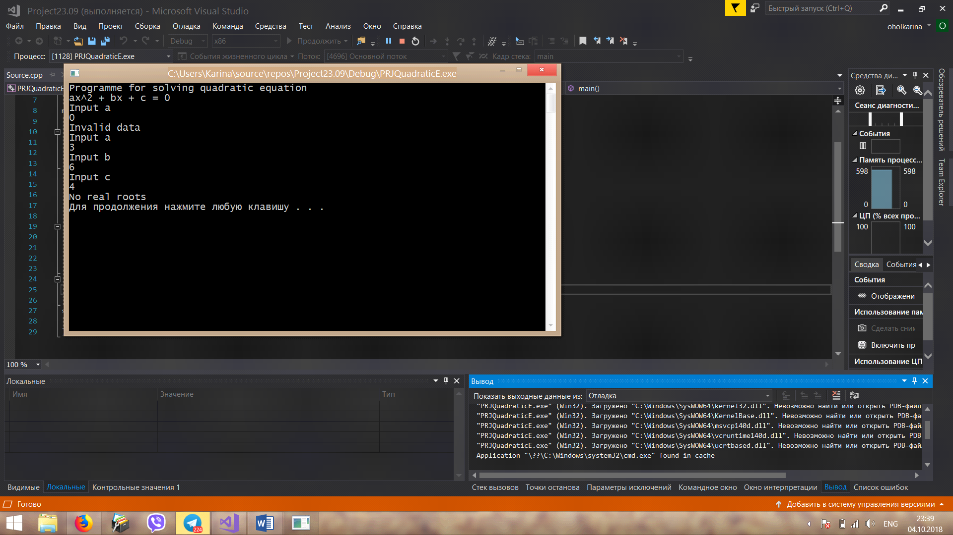

Task 2 : The code

#include<iostream>

using namespace std;

int main() {

int x, n, y = 1;

int i;

cout << "Input x";

cin >> x;

cout << "Input n";

cin >> n;

for (i = 1; i <= 2 * n; i++) {

if (i != 2 * n) {

if (i % 2 == 0) {

y *= x - i;

}

else {

y *= x + i;

}

}

}

cout << "Result : " << y << endl;

system("pause");

return 0;

}

Task 2: Execution result

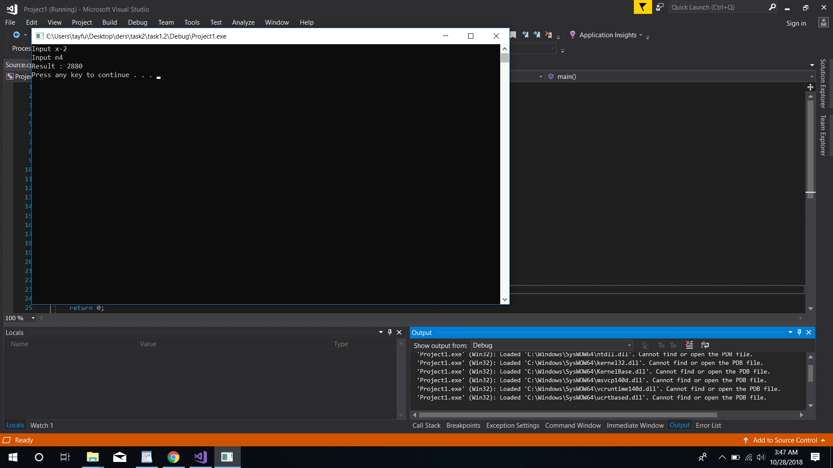

Task 3:

#include<iostream>

using namespace std;

int main()

{

int x, n;

cout << "x enter value "<< endl;

cin >> x;

cout << "n enter value" << endl;

cin >> n;

int y = 0;

for (int i = 1; i <2* n; i++)

{

if (i != 0) {

if (i % 2 == 0) {

y = (x - 2*n);

}

else {

y = x + n;

}

}

}

cout << "result" << y << endl;

system("pause");

return 0;

}

Task 3: Execution result

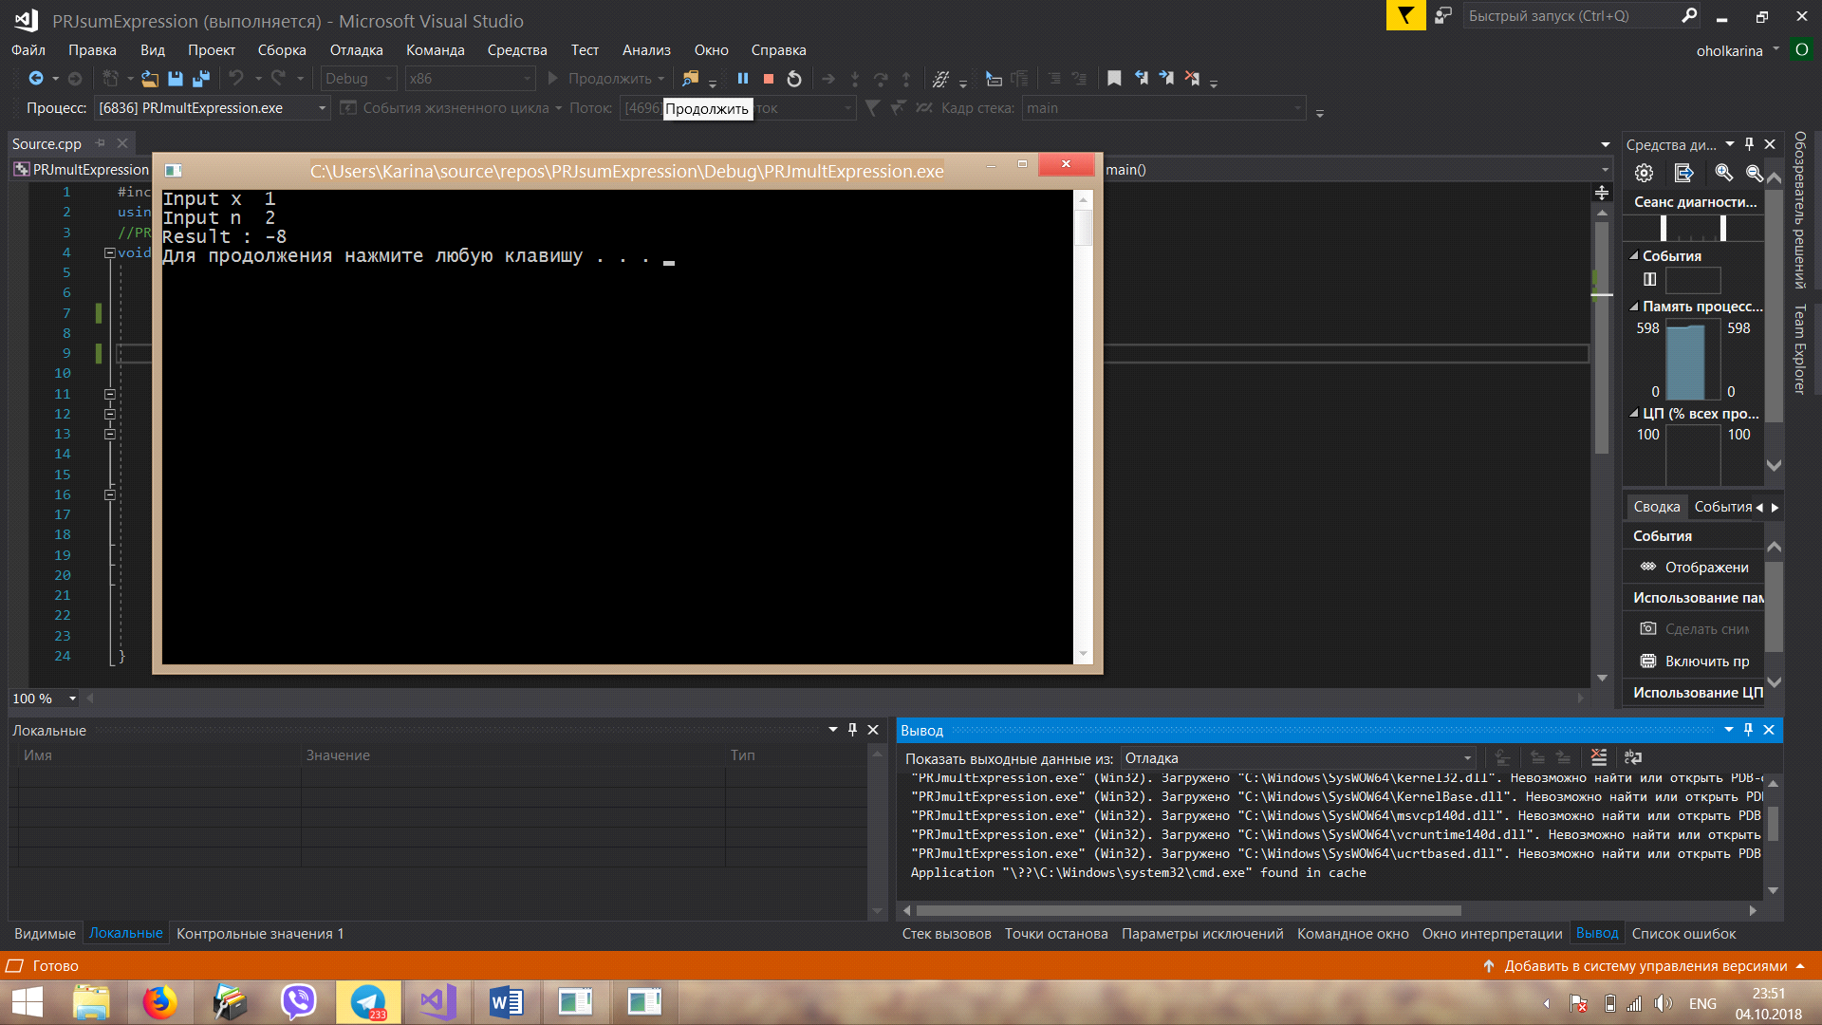

Task 4;

#include<iostream>

#include<cmath>

using namespace std;

void main()

{

double eps, y = 0;

cout << "Input eps ";

cin >> eps;

if (eps <= 0.5)

{

int i = 1;

while (1 / pow(2, i) > eps)

{

y += 1 / pow(2, i);

i++;

}

cout << "y = " << y << endl;

}

else

{

cout << "incorrect input" << endl;

}

system("pause");

}

Task 4 Execution result

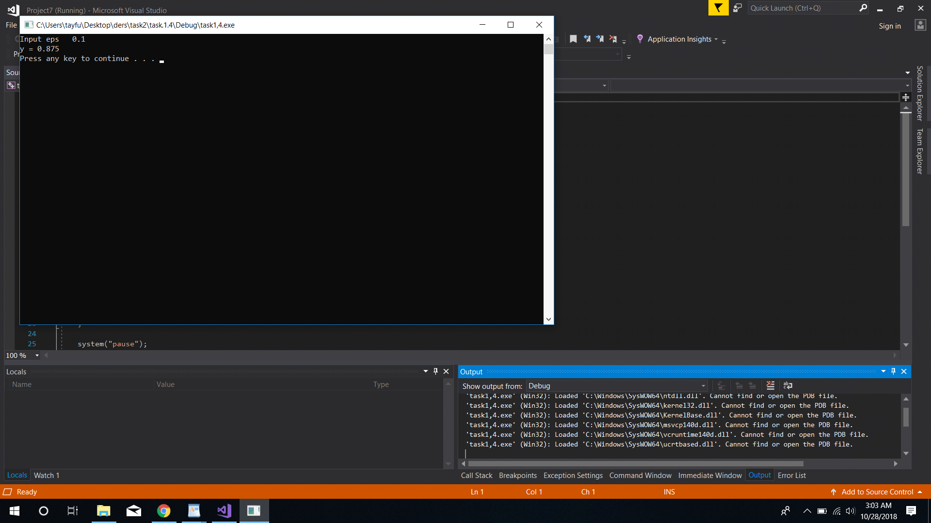

### Individual Assignment

You should develop a program that calculates values of a function in a given range. The program should implement an algorithm developed in carrying out assignment 1.3 of [previous lab](http://iwanoff.inf.ua/programming_1/LabTraining01.html).

#include "pch.h"

#include <iostream>

#include <math.h>

using namespace std;

double y = 0,x = 0;

double z;

int range_a, range_b, range_c;

int main()

{

cout << "input x ,x should be greater than 0 'zero': ";

cin >> x;

do

{

cout << "\n input lower range ,lower range can not be less than 0 'zero': ";

cin >> range_a;

} while (range_a < 0);

do

{

cout << "\n input higher range ,higher range should be greater than lower range: ";

cin >> range_b;

} while (range_a >= range_b);

do

{

cout << "\n input mid range ,mid range should be lesser than higher range: ";

cin >> range_c;

} while (range_c >= range_b);

if (x < 0)

{

for (range_a; range_a < range_b + 1; range_a++)

{

y = y + (range_a + x) * (range_a + x);

}

cout << " \n the result of the function of x is : " << y << "\n";

}

else

{

for (range_a; range_a < range_b - 1; range_a++)

{

z = 1;

for (range_c; range_c <= range_b; range_c++)

{

z = z * ((x + range_a) / (range_a + range_c));

}

y = y + z;

}

cout << "\n the result of the function of x is : " << y << "\n";

}

Excution

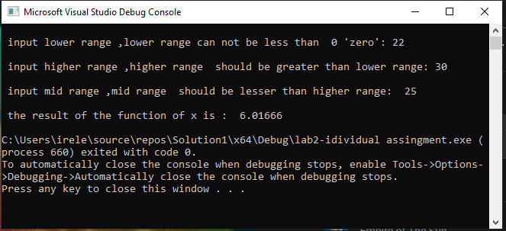

Conclusion: I received practical skills of work with basic principles of C++.I was informed about recommendations on use operators and cycles. I learned how to develop the code for the task using basic C++ operators.